24AIM54 MACHINE LEARNING OPERATIONS

DevOps is a modern approach to software development that brings development and operations teams together to deliver applications faster and more reliably. It focuses on collaboration, automation, and continuous improvement across the software lifecycle.

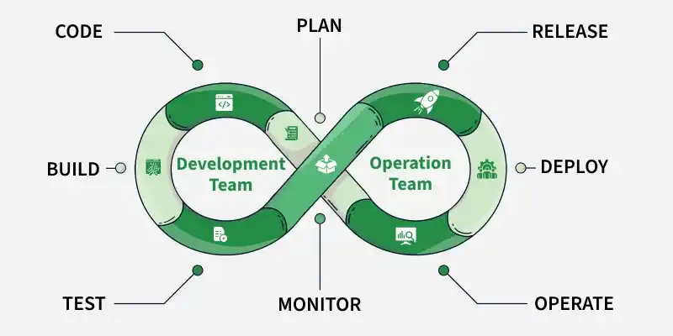

MLOPS: A set of practices that automates and streamlines the lifecycle of machine learning models from development to production

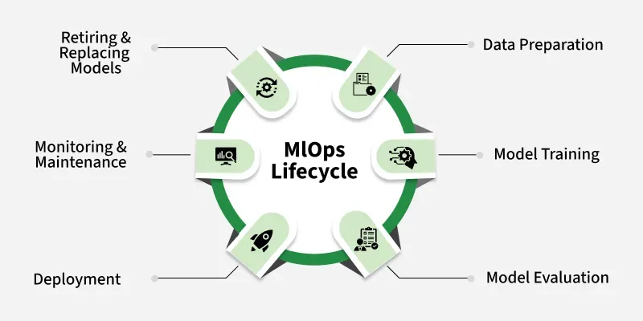

EXPERIMENT -1

Setting Up a DevOps Development Environment and Managing a Project Using Git

Aim

To understand the fundamentals of DevOps and configure a development environment for developing and managing a simple portfolio website using Git version control.

Software / Hardware Requirements
- Git bash
- Visual Studio Code or any code editor
- GitHub account

Description

DevOps promotes collaboration, automation, continuous integration, and efficient software delivery. Git is a distributed version control system that helps developers track changes, maintain different versions of a project, and collaborate effectively.

In this experiment, a simple portfolio website is developed and managed using Git.

Procedure
Step 1: Install Git Bash
Download and install Git on the system.
Verify the installation:
git --version

Step 2: Configure Git
Set the username:
git config --global user.name "Your Name"
Set the email:
git config --global user.email "your-email@example.com"
Verify the configuration:
git config --list

Step 3: Create Project Folder
Create a folder named:
portfolio-website
Open the folder using Visual Studio Code.
Step 4: Create Portfolio Website
Create a file named:
index.html
Add the following code:
<!DOCTYPE html>
<html>
<head>
<title>My Portfolio</title>
</head>

<body>

<h1>Welcome to My Portfolio</h1>

<h2>About Me</h2>
<p>I am a student interested in Artificial Intelligence and Machine Learning.</p>

<h2>Skills</h2>
<p>Python, Machine Learning, HTML, Git and GitHub</p>

<h2>Projects</h2>
<p>My Academic Projects</p>

<h2>Contact</h2>
<p>Email: student@example.com</p>

</body>
</html>

Step 5: Initialize Git Repository
Open the terminal inside the project folder.
git init
This creates a local Git repository.
Step 6: Check Repository Status
git status
The index.html file will be shown as an untracked file.
Step 7: Add the File to Staging Area
git add index.html
Alternatively:
git add .
Step 8: Commit the Project
git commit -m "Initial portfolio website"
The first version of the portfolio website is now stored in the local Git repository.
Verify the commit:
git log
git log --oneline

Important Git Commands
Command | Purpose
git init | Creates a Git repository
git status | Displays repository status
git add | Adds files to staging
git commit | Records changes / adds to local repository
git log | Displays commit history

Result
Thus, a DevOps development environment was successfully prepared, a simple portfolio website was created, and the project was successfully initialized and maintained using Git version control.

